shows file or directory, size, modified date and time, file or folder name and owner of the file, and its permission.

Shows hidden files

With a combination of **-lh** option, shows sizes in a human-readable format.

using the **-F** option with the **ls** command will add the '/' character at the end of each directory.

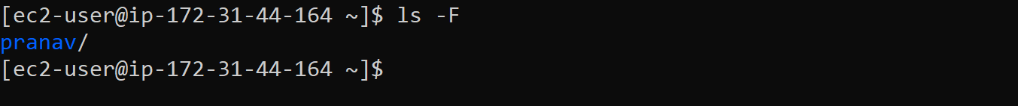

**ls -R** option will list very long listing directory trees. See an example of the output of the command.

A combination of **-ltr** will show the latest modification file or directory date as last.

With a combination of **-lS** displays file size in order, will display big in size first.

We can see some numbers printed before the file/directory name. With **-i** options list file/directory with an inode number.

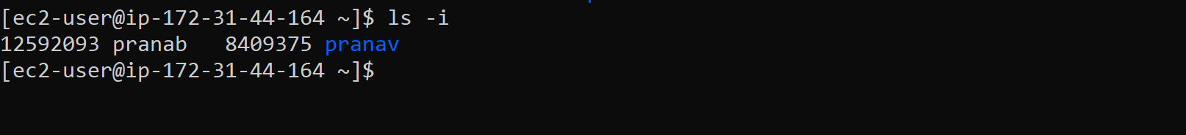

Show version of ls commands

Show different option for using ls command

Ls-l /tmp displays the file under the tmp folder. Id parameter displays the info of temp directory



To display uid and gid of files and directories

 an alias for **ls** command, when we execute ls command it’ll take the **-l** option by default and display a long listing as mentioned earlier.

We can check alias present in the system

We can unalias by using unalias command



 To list contents of any directory, for example **/etc** directory use:

**How to Sort Output of ‘ls’ Command By Last Modified Date and Time**

To list files in a directory and sort them last modified date and time, make use of the -t option as in the command below:

$ls -lt

 If you want a reverse sorting files based on date and time, you can use the -r option to work like so:

$ls -ltr

**To list the contents of a directory with times using style, we need to choose any of the below two methods.**

# ls -l –time-style=[STYLE]

STYLE has four options

full-iso

long-iso

iso

locale

+%H:%M:%S:%D

Contents of directory can be listed using **ls command** in various format as suggested below.

1. across
2. comma
3. horizontal
4. long
5. single-column
6. verbose
7. vertical

# ls –-format=across

# ls --format=comma

# ls --format=horizontal

# ls --format=long

# ls --format=single-column

# ls --format=verbose

# ls --format=vertical

**Sort the contents of directory on the basis of extension, size, time and version.**

We can use options like --extension to sort the output by extension, size by extension --size, time by using extension -t and version using extension -v.

Also we can use option --none which will output in general way without any sorting in actual.

# ls --sort=extension

# ls --sort=size

# ls --sort=time

# ls --sort=version

# ls --sort=none

We can manually assign the size of the screen

Set manual tab-size of the contents of the directory.default tab size is 8

List all the files by size in descending order(default)

Ls -laS

In reverse order

Ls -laSr

Note

a – all file

h –human redable

R –recursive list all directories

S –sort in descending

r—sort in ascending

l –long print

lt— long list with latest changes